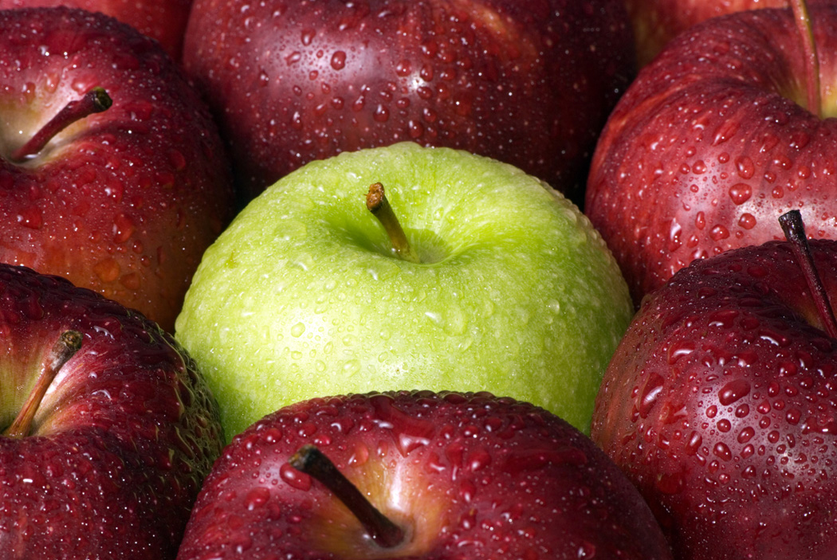
QUIZ use as a study guide

- What are some things Jonas begins to perceive and eventually begins to see?
- How does The Giver feel after he transmits the first memory?
- What does Jonas learn about climate control?
- What does Jonas learn he is seeing in the apple, Fiona’s hair, the faces in the crowd, and in the sled?
- Where do you think the idea of Sameness came from, and why were there no differences in people other than gender and assigned jobs?
- When Jonas learns all about colors, he claims, “It isn’t fair that nothing has color.” Why does he say this? Use supportive evidence.
- What are the people in the community being protected from, by not having to make choices?
- What memory was worse than the “sunburn”? (transmitted by The Giver)
- The Giver explains to Jonas that he will gain something by being the holder of memories. What will Jonas gain?
- Why does The Giver ask Jonas for forgiveness?
- After the “horrible” memory, The Giver is gentle with Jonas, giving him tidbits of happy memories. What are some of these memories?
- What is The Giver’s favorite memory?

