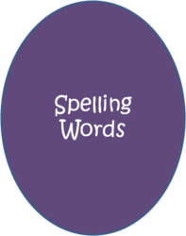
Spelling Week 1
Emphasis: Noun Suffixes

Word List:
- historian
- politician
- comedian
- pianist
- librarian
- novelist
- pharmacist
- custodian
- criticism
- idealism

Spelling strategy: Remember the meanings of noun suffixes -ian and –ist (“one who does or studies”) and of the noun suffix –ism (“the act, profession , or theory of”).

A: Define the 10 spelling words above.
Graded: Word, spelled correctly, definition =30pts.
B: Create a story using each spelling word. The spelling words must be used as listed above (noun). Underline the spelling words in the story. Each spelling word must appear in its own sentence but may be used more than once throughout your story. Have fun with it and be creative. BTW- Spelling counts!
Graded: Sentence per word (1), word(1), spelled correctly (1), word underlined (1), content meaning (2) = 60pts.
Graded: Overall creativity, cohesiveness, and comprehension of words and sentence structure =10pts. Does it make sense?
TOTAL 100pts.

Reminder: Please make sure to punctuate your sentences.

