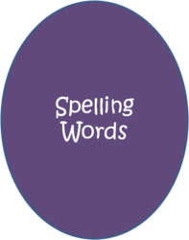
Spelling Week 3
Emphasis: Academic Vocabulary B-1

Word List:
- Available
- Cater
- Customary
- Dissuade
- Entrepreneur
- Firebrand
- Hazard
- Homicide
- Indifference
- Indignant

A: Define the 10 spelling words above.
Graded: Word, spelled correctly, part of speech, definition, 2 synonyms, and 2 antonyms. 80 pts
B: Create a story using each spelling word. The spelling words must be used as listed above (part of speech). Underline the spelling words in the story. Each spelling word must appear in its own sentence but may be used more than once throughout your story. Have fun with it and be creative.
BTW- Spelling counts!

Graded: Sentence per word (1), word (1), spelled correctly (1), word underlined (1), content meaning (2) = 60pts.
Graded: Overall creativity, cohesiveness, and comprehension of words and sentence structure =10pts. Does it make sense?
TOTAL 150pts.

Reminder: Please make sure to punctuate your sentences.

