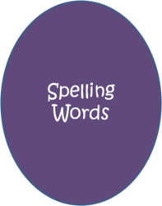
Spelling Week 8
Emphasis: Vowel Changes

- resume
- resumption
- induce
- induction
- abstain
- abstention
- presume
- presumption
- revise
- revision
- atrocious
- atrocity

*Challenge: ferocious, ferocity, grateful, gratitude

Word List:
Spelling strategy: Knowing how the vowels change in one pair of related words can help you predict changes in other pairs with the same root.
A: Define the 12 spelling words above.
Graded: Word, spelled correctly, definition =36pts.
B: Create a story using each spelling word. The spelling words must be used as listed above (noun). Underline the spelling words in the story. Each spelling word must appear in its own sentence but may be used more than once throughout your story. Have fun with it and be creative. BTW- Spelling counts!
Graded: Sentence per word (1), word (1), spelled correctly (1), word underlined (1), content meaning (2) = 72pts.
Graded: Overall creativity, cohesiveness, and comprehension of words and sentence structure =12pts. Does it make sense?
TOTAL 120pts.

Reminder: Please make sure to punctuate your sentences.

