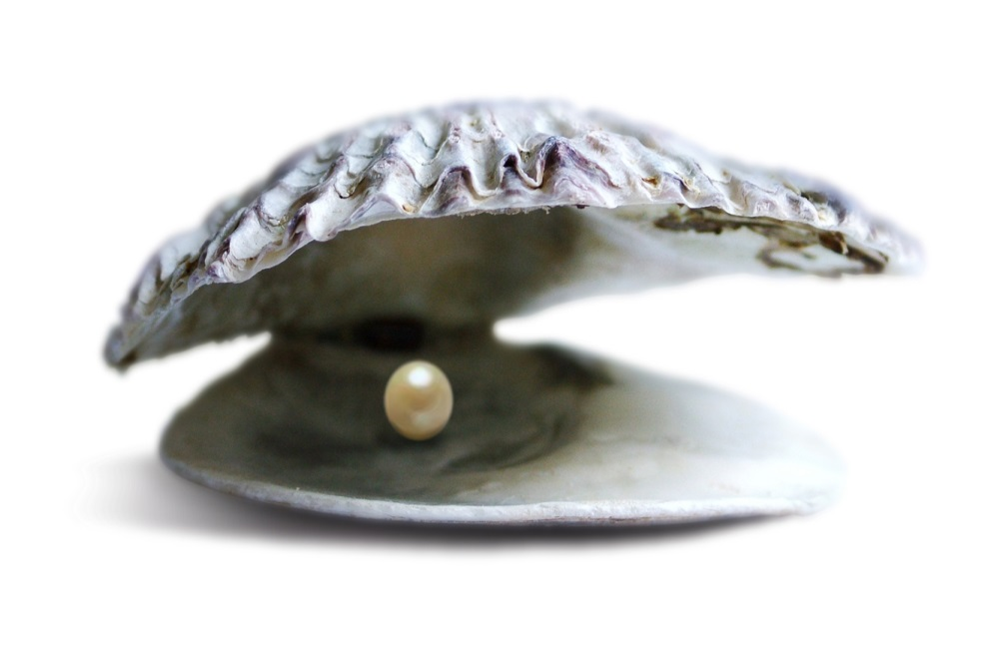
The Pearl by John Steinbeck

Chapter 6 Questions
- Write a summary of the major events for chapter 6.
- What was the mood and setting like when Kino’s family exited the town?
- How did this reinforce or make the story better? Explain.
- What time of day did they leave town?
- What clever thing did Kino do to try to fool anyone that might be tracking them?
- What convinces Kino that the pearl was not valueless as Juana suggested to him.
- When or what did Kino discover that told him that his escape might not be so easy?
- What did Kino see “gleaming in the sun” that one of the trackers had in his hand?
- What happens to Coyotito at the little water pool in the high desert?
- What did Kino finally do with his priceless pearl?
- A symbol can change its meaning during the course of the novella. How does the pearl change its meaning during the course of this novella?

