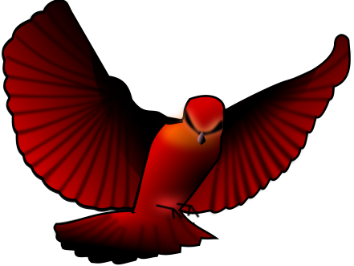
Chasing Redbird Vocabulary
Chapters 15-19, “Lost and Found” to “Accused”

- Gall bladder (88)
- Nettles (89)
- Badger (89)
- Jiving (94)
- Boogie-woogie (94)
- Ajar (94)
- Eerie (97)
- Disheveled (97)
- Drooling (97)
- Muffled (97)
- Brambles (98)
- Solemn (98)
- Parson (100)
- Sophistication (100)
- Briars (102)
- Wee (104)
- Lurking (104)
- Queasy (107)
- Hearty (109)
- Frazzled (109)

