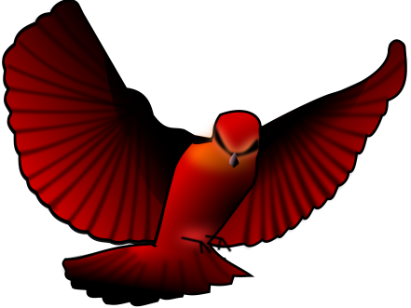
Chasing Redbird Vocabulary
Chapters 26-28, “Provision” to “Baby in the Bag”

- flare (142)
- lug (143)
- carted (144)
- stewed (144)
- floundered (145)
- careening (146)
- doodads (149)
- antsy (150)
- makeshift (151)
- ravenous (152)
- tamping (154)
- makeshift (151)
- prickly (152)
- tamping (154)
- Revelation (155)
- Drones (156)
- Stupor (156)
- Burrowed (158)
- Brachiopods (160)
- Larches (162)
- Mesmerizing (162)
- Muddles (164)

