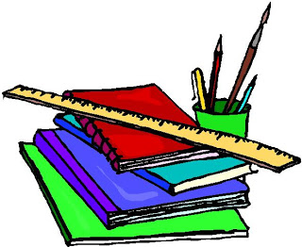
Holy Family School Supply List
Middle School Grades 6th-8th
- 2 Packages of Copy Paper
- 2 Boxes of Tissues
- 1 Package of Dry Erase Markers
- 1 Can of Disinfectant
- Paper Towels
- Clorox Wipes
- One Bottle of Hand Sanitizer • Face mask (ALL students must wear a face mask to and during school). Please put names on the inside of the mask.
- 1 extra face mask in a zip lock bag with student’s name inside the mask and on the outside of the bag.
- Plastic supply box.

English Language Arts – All Grades
- 1 Composition notebook 7 ½” x 9 ½”
- 3 ring binder (OR folder with prongs and pockets for paper and assignments)
- College ruled paper
- Crayola Colored pencils
- Hand Held pencil sharpener for colored pencils
- flash drive - ** only if student does not have internet, or personal email
- *Tons of pencils* (everyday )
- *Tons of pens (blue or black, may be colored Everyday )*

