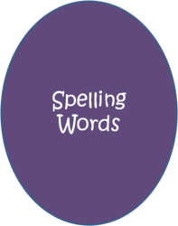
Spelling Week 16
Emphasis: Words from Places

- possession
- opossum
- accommodate
- embarrass
Peut-être , je ne sais pas . Oui. Non!!!
- paraffin
- affectionate
- shrubbery
- harass
Est ce que tu vas bien?
- succinct
- renaissance
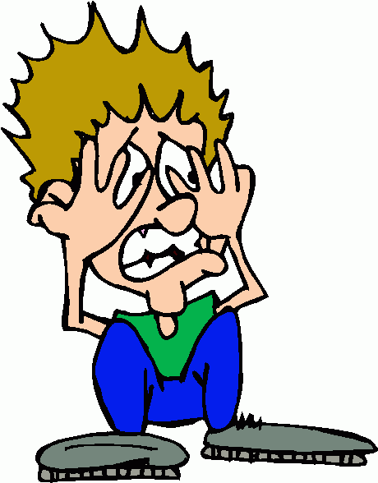
- irrevocable
- collateral

*Challenge: reconnaissance, cancellation, necessary

Word List:
Spelling/Vocabulary Strategy: Remember that double consonants can occur when a prefix is absorbed or before a suffix beginning with a vowel. Double consonants in other words must be remembered.
A: Define the 12 spelling words above.
Graded: Word, spelled correctly, definition =36pts.
B: Create a story using each spelling word. The spelling words must be used as listed above (noun). Underline the spelling words in the story. Each spelling word must appear in its own sentence but may be used more than once throughout your story. Have fun with it and be creative. BTW- Spelling counts!
Graded: Sentence per word (1), word (1), spelled correctly (1), word underlined (1), content meaning (2) = 72pts.
Graded: Overall creativity, cohesiveness, and comprehension of words and sentence structure =12pts. Does it make sense?
TOTAL 120pts.

Reminder: Please make sure to punctuate your sentences.

